**Alert Rule Documentation – 4xx/5xx Error Monitoring**

**1. Overview**

This document explains the configuration of the **4xx/5xx error alert rule** in Grafana. The rule is designed to notify stakeholders whenever the percentage of 4xx/5xx client errors in services crosses a defined threshold, ensuring quick detection and resolution of application issues.

The alert integrates with:

* **Microsoft Teams** channel (for collaboration and incident response)
* **Email notifications** (for reliability and audit trail)

**2. Data Source & Input**

* **Data Source**: Infinity (CSV / Inline Backend Parser)
* **Format**: Table
* **Input Fields** (from the CSV):
  + service → Application/service name
  + time → Timestamp of data sample
  + service_availability_pct → Availability percentage
  + available_servers / unavailable_servers → Infra health metrics
  + total_requests → Total incoming requests
  + pct_2xx → Successful request percentage
  + pct_4xx → Client error percentage
  + pct_5xx → Server error percentage
  + p99_latency_s → Latency at 99th percentile

**Data Row:**

service,time,service_availability_pct,available_servers,unavailable_servers,total_requests,pct_2xx,pct_4xx,pct_5xx,p99_latency_s

All,2025-08-26T00:00:00Z,100.0,84,0,10946,97.0,1.1,1.9,1.68

Order Management,2025-08-26T00:00:00Z,100.0,24,0,5798,98.9,0.7,0.4,1.75

Account Management,2025-08-26T00:00:00Z,100.0,30,0,5148,97.9,2.1,0.0,1.60

Product Config,2025-08-26T00:00:00Z,100.0,30,0,0,0.0,0.0,0.0,0.0

**3. Alert Rule Configuration**

**Rule Name**

* **Name**: 4xx error and 5xx error

**Query & Condition**

* **Query A**: Reads the CSV data using Infinity datasource.
* **Expression C (Threshold)**:
  + Input: pct_4xx/pct_5xx (from Query A)
  + Condition: **Is above 0.5%**
  + Recovery Threshold: Custom (auto-clears when pct_4xx ≤ 0.5%)

**Meaning**: If the percentage of 4xx/5xx errors exceeds **0.5%** of total requests, an alert will be triggered.

**4. Alert Evaluation Behavior**

* **Evaluation Group**: error
* **Evaluation Interval**: Every 1 minute
* **Pending Period**: 0s → alert triggers immediately when threshold is breached
* **Keep Firing For**: 1s → alert resolves immediately when back to normal
* **No Data & Error Handling**: Default

**5. Folder & Labels**

* **Folder**: GrafanaCloud
* **Labels**: (Optional, none configured yet – could add team=observability or priority=high in future)  
    
    
  Configured Notification format  
  A screenshot of a computer screen

  AI-generated content may be incorrect.

**6. Notification Routing**

* **Contact Points Configured**:
  1. **Microsoft Teams** channel – real-time collaboration and visibility

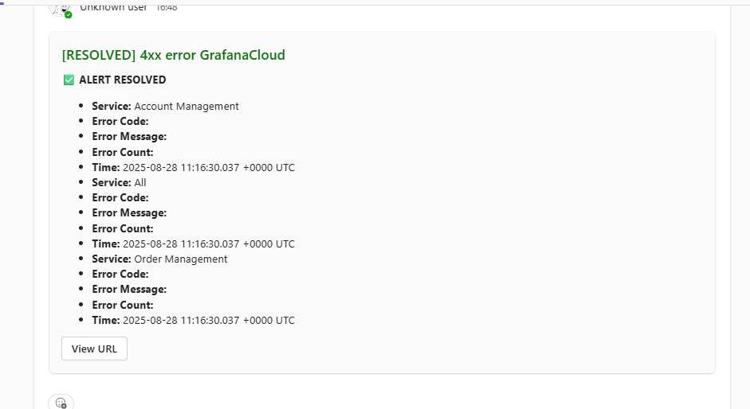

* 1. **Email** – detailed alert traceability and archival

